

**AMERICAN INTERNATIONAL UNIVERSITY–BANGLADESH (AIUB)**

**Faculty of Science and Technology**

**Dept. of Computer Science**

**COURSE: SOFTWARE ENGINEERING**

**Fall 2025-2026**

**Section:V**

**Group No: 04**

**Software Requirement Specification [SRS] Document On**

***FOOD WASTE REDUCTION PLATFORM***

**Supervised By:**Zinniya Taffannum Pritee

**Submitted By**

|  |  |  |
| --- | --- | --- |
| **Name** | | **ID** |
| **1.** | Tawfiqul Hasan | 23-54422-3 |
| **2.** | Md. Rayatul Bari Rahin | 23-53450-3 |
| **3.** | Md. Tanzim Wasif Shah | 23-53449-3 |
| **4.** | Ibna Al Shaid Nipun | 23-53457-3 |

Table of Contents

1. INTRODUCTION 3

1.1 Selection of Process Model: 4

2. SCOPES & FEATURES 5

2.1 Scope 1: Surplus Food Analytics and Expiry Management 5

2.2 Scope 2: Intelligent Matching & Donation System 5

2.3 Scope 3: Pickup and Delivery Coordination and Food Safety 5

2.4 Scope 4: Volunteer & Community Impact Analytics 5

3. USE CASE DIAGRAM 6

4. USER STORY TABLE 7

5. REQUIREMENT TRACEABILITY MATRIX 7

5.1 Functional Requirements 8

5.2 Non-Functional Requirements 9

6. GIT WORKFLOW 10

6.1 Git clone 10

6.2 Git push 11

6.3 Git PULL 12

7. FIGMA DESIGN 14

8. TRELLO 19

9. SOFTWARE TESTING 21

# INTRODUCTION

Food waste has emerged as a significant social, environmental and economic problem all over the globe. Every year, tons of edible food go to waste at home, restaurants, retail and supply chain levels. This waste results in not only a completely unnecessary financial loss, but also the adding of pressure to landfills and an increase in greenhouse-gas emissions. Yet at the same time, many neighborhoods remain beset by food insecurity. This breakdown betrays a large disparity between excess food and those who require it.

One of the biggest obstacles is that there is no easy, effective way to connect food providers with people or groups in search of surplus. Restaurants, hotels, grocery stores and homes frequently have extra food without an easy way of managing it, donate it or rotate it those who need it. Consumers also lack knowledge and information in real time that can lead to unnecessary trash at home, such as the expiration date tracking or receiving reminder.

A Food Waste Reduction Platform can fill the gap by providing a system for sharing, donating, tracking surplus food and raising awareness. As it links the giver; receiver and community and charitable groups in one online infrastructure, it aims to decrease waste while also fostering marginalized communities as well as ethical consumption.

**OBJECTIVES**

* Decrease food waste production for consumers, households and businesses.
* Keep a digital log of food surplus and expiry date
* Facilitate the real-time act of donation and sharing between donor and recipient parties
* Ensure NGOs, shelters and community programs have access to stable food sources.
* Use reminders and awareness tools for sustainable consumption
* Provide transparent and auditable redistribution mechanism
* Create an eco-space by minimizing waste
* Maximize public engagement in community-service projects

**PROPOSED SOLUTION**

The solution is thus a central, user-centered digital service that through proper redistribution and smart governance will seek to reduce food waste.

**Surplus Food Tracking:** Extra food with expiration date, quantity and category can be recorded by users for instant view.

**Smart Donation & Sharing System**: Nearby NGOs/homes/families/individuals can instantly claim available food via automated matching.

**Pickup & Delivery Coordination**: Scheduling tools combination with volunteers or delivery partners to provide efficient transportation.

**Food Safety & Quality Monitoring:** Automated inspections as well as guidelines let your shared food stay safe to eat.

**Community Engagement**: Features Gamification, green campaigns and sustainability education combine to promote engagement and environmentally friendly behavior.

**Data Analytics & Reporting:** It monitors the waste reduction, shares the amount of food and its impact on community with real insights.

**Scalability & Accessibility:** The user-friendly design is compatible making it available to households, restaurants, retailers and small businesses.

TARGET AUDIENCE

* Family: Waste less and share extra food.
* Restaurants & Cafes: Give surplus food a safe drop with maximum ease
* Grocery Stores & Businesses: Post your soon to expire stock for redistribution
* NGOs & Community Shelters: Get regular supply of food.
* Volunteers & Delivery Networks: Help deliver donated food
* Ecologically Individuals: Help the environment to maintain sustainability

EXPECTED IMPACT

* Major decrease in food waste from households and commercials causes
* More food assistance for the downtrodden
* Improved environmental sustainability
* Strengthened community cooperation
* Enhanced awareness about responsible consumption
* Less waste in landfills and less carbon emissions

## Selection of Process Model:

The Food Waste Reduction Platform is a system that helps people share extra food. Many users use it. Donors, NGOs, receivers, volunteers and admins all work together. The system has many features and these features may change with time. Because of this, the Scrum (Agile) model is the best choice for this project.

The reasons for choosing the Scrum model are given below:

* **Requirements can change easily**  
  This project may need new ideas later. For example, better matching, rewards, or more reports. Scrum allows changes during development. This helps the team improve the system step by step.
* **Work can be done in small parts**  
  The system can be built part by part. First login and registration. Then food listing. Then donation and delivery. Scrum supports this small and clear way of work.
* **Many user roles need feedback**  
  Different users use the system in different ways. Their feedback is important. Scrum allows regular checking and improvement after each sprint.
* **Testing happens again**  
  The project has many test cases. Scrum supports testing in every stage. This helps find problems early and fix them fast.
* **Good for teamwork**  
  The project is done by a group. Tasks can be shared easily. Scrum helps the team stay connected and focused.

In conclusion, the Scrum model is suitable for the Food Waste Reduction Platform. It supports change, teamwork, and step by step development. Using Scrum will help to make a useful and reliable system that can spread in the future.

# SCOPES & FEATURES

## Scope 1: Surplus Food Analytics and Expiry Management

* Users can enter surplus food in terms of categories, quantity, and expiry date.
* To reduce the waste of food at home, the system sends reminders before food goes bad.
* Gives you a digital record for boosted food tracking.

## Scope 2: Intelligent Matching & Donation System

* It instinctively finds the nearest donors for NGOs, shelters or quote unquote needy people.
* Food can be claimed by receivers on demand.
* Ensures quick and effective re-distribution of excess food.

## Scope 3: Pickup and Delivery Coordination and Food Safety

* Delivery partners or volunteers can schedule pick-up and drop-off.
* Route optimization ensures timely delivery.
* Cliff provides details about food safety guidelines and timestamps to allow the donated food to maintain safety.

## Scope 4: Volunteer & Community Impact Analytics

* Involves gamification, social awareness campaigns, and sustainability education.
* Keeps track of reduction of waste, donations given, and the effect on the environment
* Provides an incentive for the community to get involved by being transparent and offering a utility within the token.

# USE CASE DIAGRAM

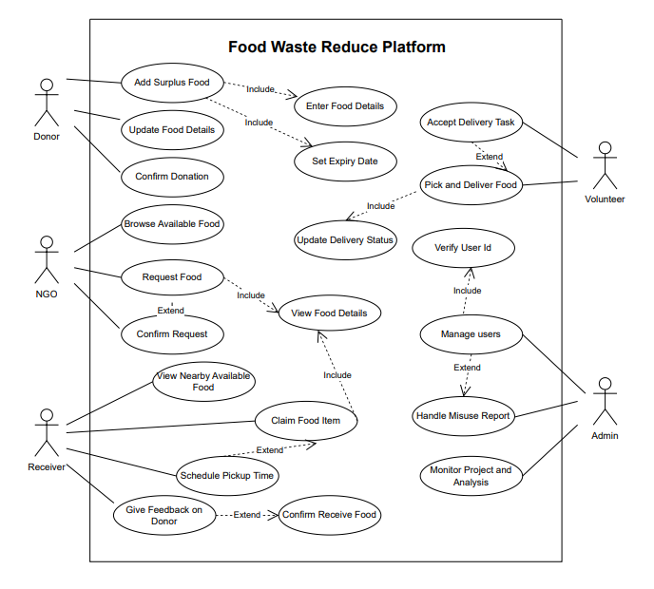

Figure: Use Case Diagram of Food Waste Reduction Platforms

Food Waste Reduction Platform Use Case Diagram According to different actors in the system and how they engage with the system to facilitate food donation, distribution, and management. Donor: Adding excess food, Updating food details and Confirming donation All these actions requires entering food detail with expiry dates perishable nature of the food. The NGO Recipient can view the listed available food and place a request on the items they wish to request, the request process includes viewing the details of the food, right until confirming the request. The Receiver, either a person or a family, can see available excess food around them, pick up food, arrange when to collect them, and leave optional feedback for the donors; picking up food means seeing their details (which may also enter the confirmation of receipt). The Volunteer or delivery partner who is notified and accepts the order is responsible for food pickup and drop-off while updating delivery status. The Admin can manage users, verify identities, monitor analytics, and handle reports of misuse (or anything else they want) and keep the system running smoothly. All of these interactions together provide an end-to-end view of the donor-receiver flow through the specific roles and interactions that must occur to facilitate the effective, safe, and transparent redistribution of food.

# USER STORY TABLE

|  |  |  |  |
| --- | --- | --- | --- |
| **As a / An** | **I want to** | **So that** | **Acceptance Criteria** |
| Donor | add surplus food | I can donate extra items instead of wasting them | System allows entering food name, quantity, category, and description |
| Donor | update food details | the information remains accurate | Updated food information is saved and shown correctly |
| Donor | confirm my donation | I know it has been successfully submitted | Donation status changes to confirmed |
| NGO Recipient | browse available food | I can request items for our community | List of available food items is displayed |
| NGO Recipient | request food | we can receive supplies when needed | Requested food is marked as pending |
| NGO Recipient | confirm received food | the donation record is complete | Donation status changes to received |
| Receiver (Individual/Family) | view nearby available food | I can find support easily | Food list is shown based on location |
| Receiver | claim food items | I can receive food safely and quickly | Claimed food is reserved for the receiver |
| Receiver | schedule a pickup time | collecting the food becomes convenient | Pickup time is saved and confirmed |
| Receiver | give feedback on the donor | I can share my experience | Feedback is stored and visible to admin |
| Volunteer / Delivery Partner | accept delivery tasks | I can help distribute food | Task status updates to accepted |
| Volunteer / Delivery Partner | update delivery status | the platform reflects real-time progress | Status updates to Picked Up / On the Way / Delivered |
| Admin | verify user identities | the platform remains secure | User status changes to verified |
| Admin | manage users | the system runs smoothly | Admin can add, update, or remove users |
| Admin | handle misuse reports | inappropriate activities are controlled | Reports can be reviewed and resolved |
| Admin | monitor reports and analytics | I can understand system performance | Analytics dashboard is accessible |

# REQUIREMENT TRACEABILITY MATRIX

## Functional Requirements

**Donor Requirements:**  
Donor will be able to add any surplus food with the details regarding Food name, Quantity, Category and Expiry Date under this system so that excess food can be donated rather than being wasted. So, to make sure that the donation process is accurate and complete, the system will need to provide features that can enable the donors to update the details of their food and confirm its donation. These are all high priority tasks and confirming a donation is medium priority.

**NGO Recipient Requirements:**  
NGO recipients allow to view what food items are available and place an order for food items they need, making the process of getting food to communities more efficient. NGOs recipients must also be able to verify food received, to keep the donation records intact and transparent. As for browsing and getting the food, these should be set as a high priority and confirmation should be medium priority.

**Individual Receiver Requirements:**  
The system shall allow individual receivers see available food nearby and claim items, thus enables food equity and accessibility. Also allow receivers to schedule their own pickup time and leave feedback to the system to make collection more convenient and increase trust on the platform. Viewing and claiming food are **high-priority tasks**, while pickup scheduling and feedback are **medium to low priority.**

**Volunteer / Delivery Partner Requirements:**  
The system will allow delivery partners or volunteers to accept delivery tasks and update the delivery status, which allows them to transport the food with real-time tracking and pick up the food quickly. These are high-priority operational tasks.

**Administrator Requirements:**  
The system will enable the admins to manage the users, verify personal identity verification, report misuse and analytics monitoring, to ensure that the system is secure, trustworthy and streamlined. These are high-priority administrative tasks.

## Non-Functional Requirements

**1. Availability**

* The system should be available most of the time
* Users should not face frequent downtime
* Maintenance should be done during low usage time

**2. Performance**

* Pages should load within a few seconds
* Login and food listing should be fast
* Nearby food results should appear quickly

**3. Security**

* Only authorized users can access their features
* Admin actions should be limited to admin users
* User passwords and personal data must be kept safe

**4. Usability**

* The system should be easy to use
* New users should learn the system quickly
* Buttons, menus, and text should be clear

**5. Reliability**

* The system should not crash often
* Food and delivery data should be saved correctly
* Data should not be lost easily

**6. Maintainability**

* Bugs should be easy to fix
* Updates should not break core features
* The system should support future improvements

# GIT WORKFLOW

## Git clone

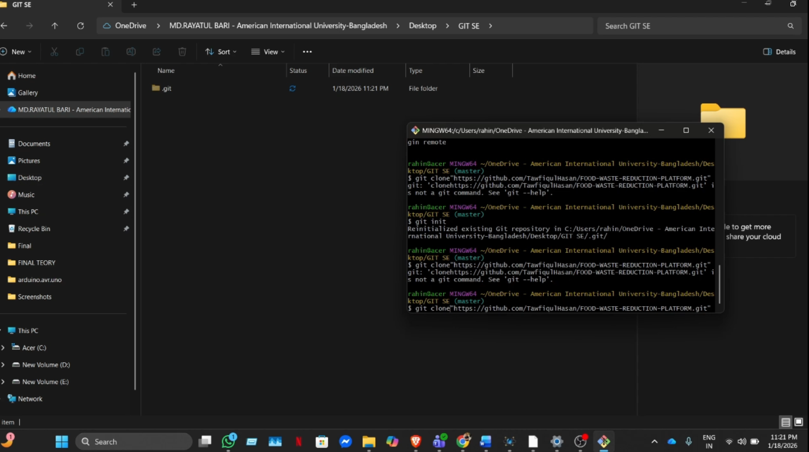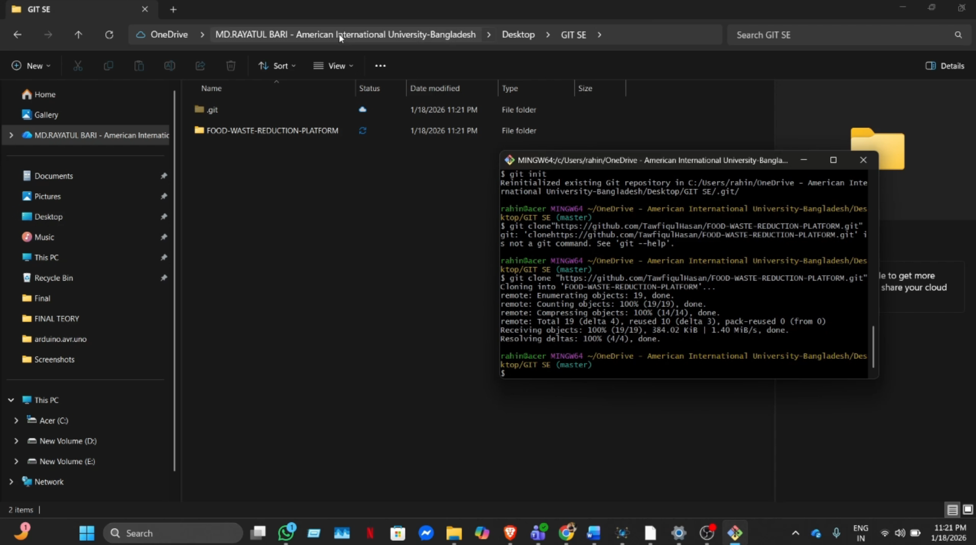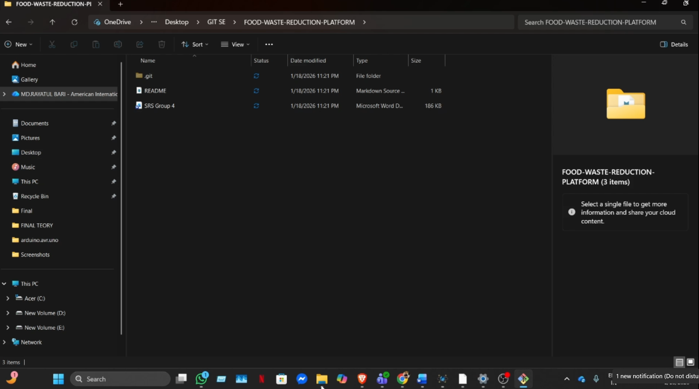

## Git push

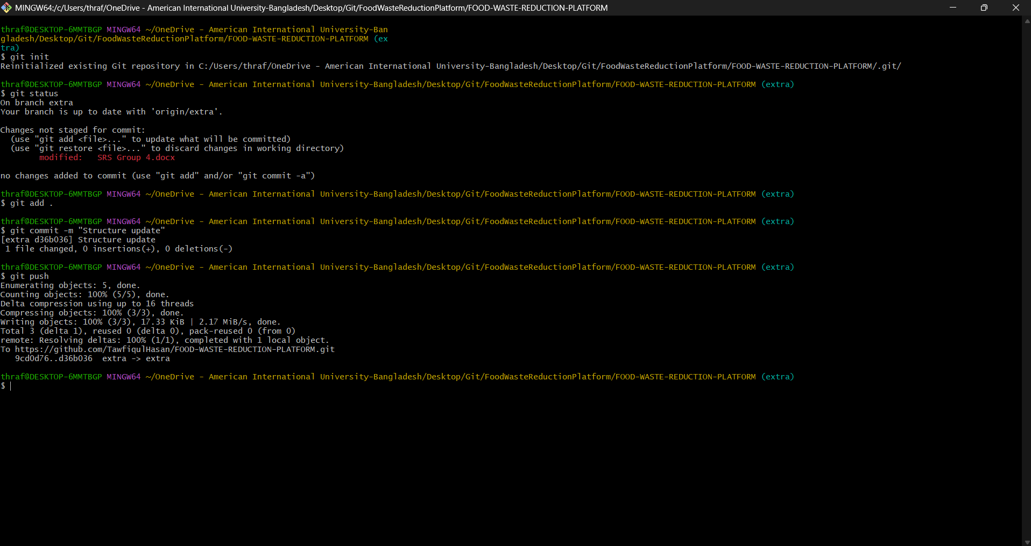

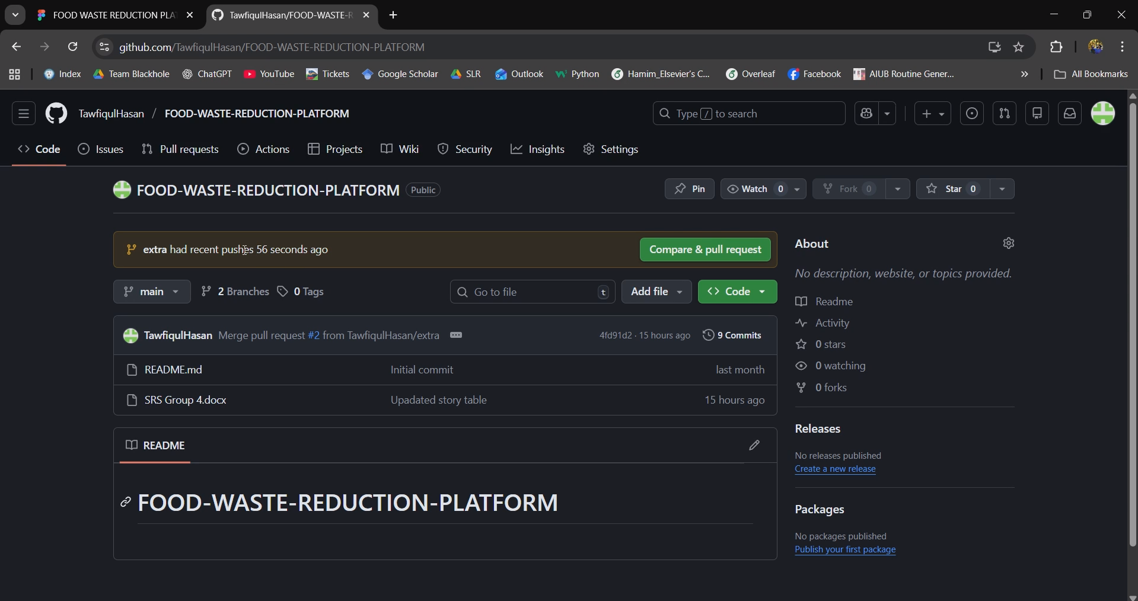

## Git PULL

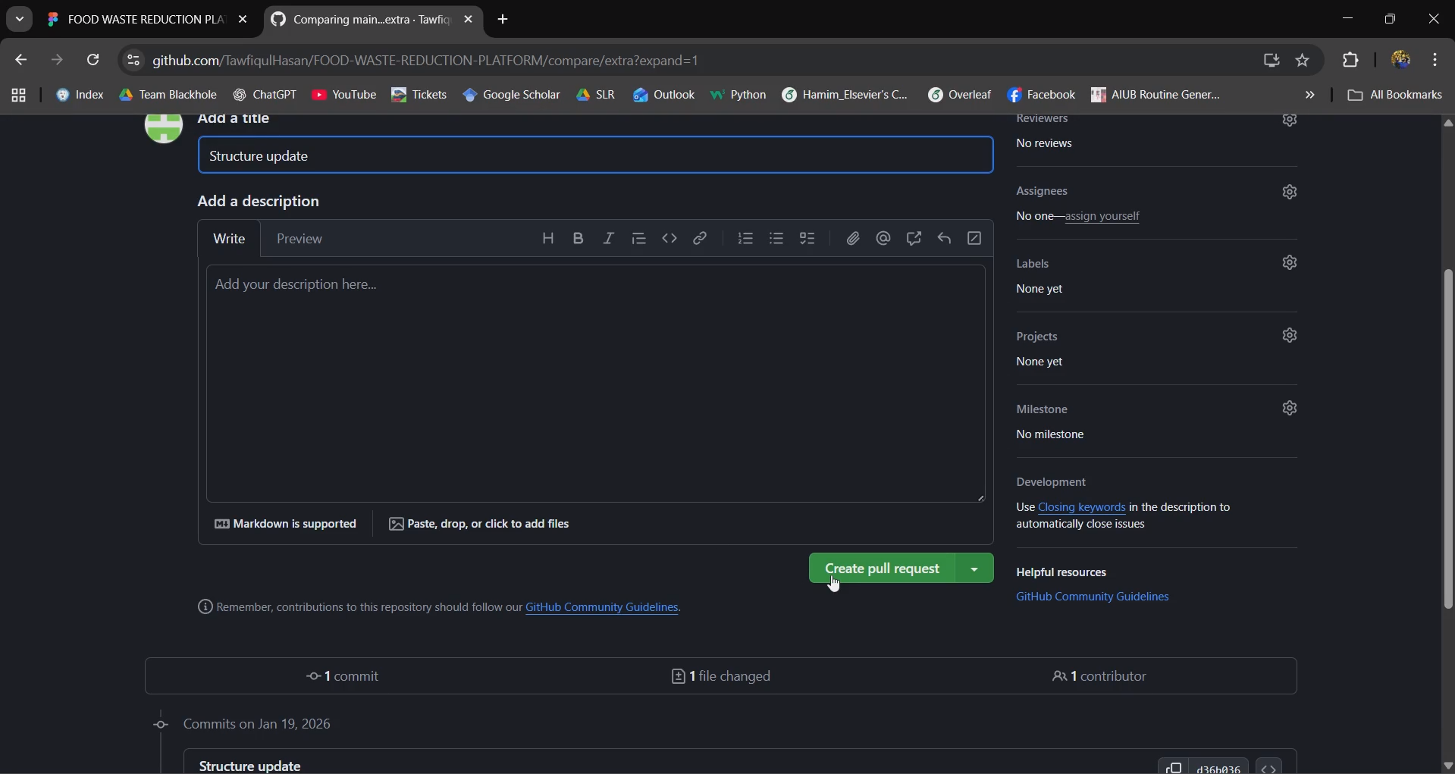

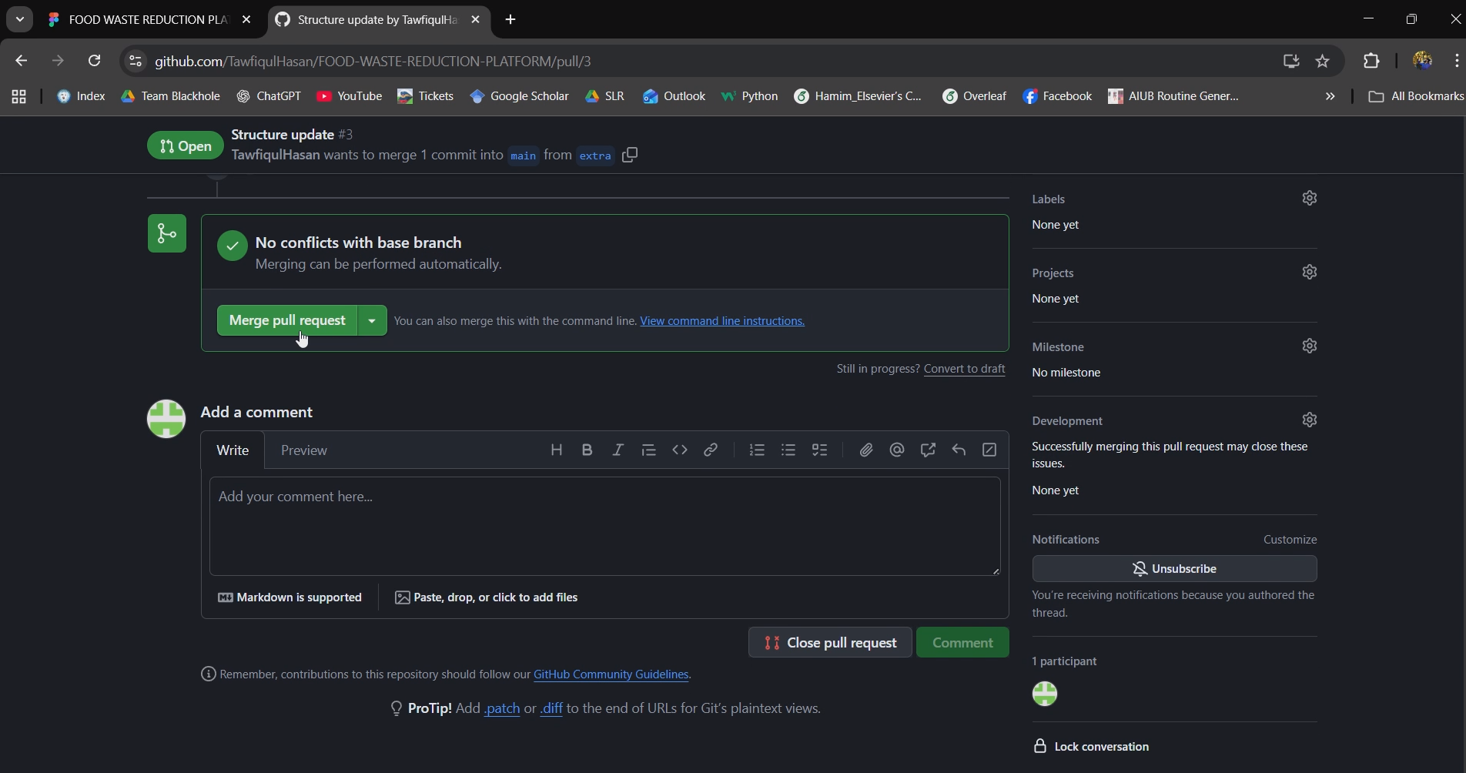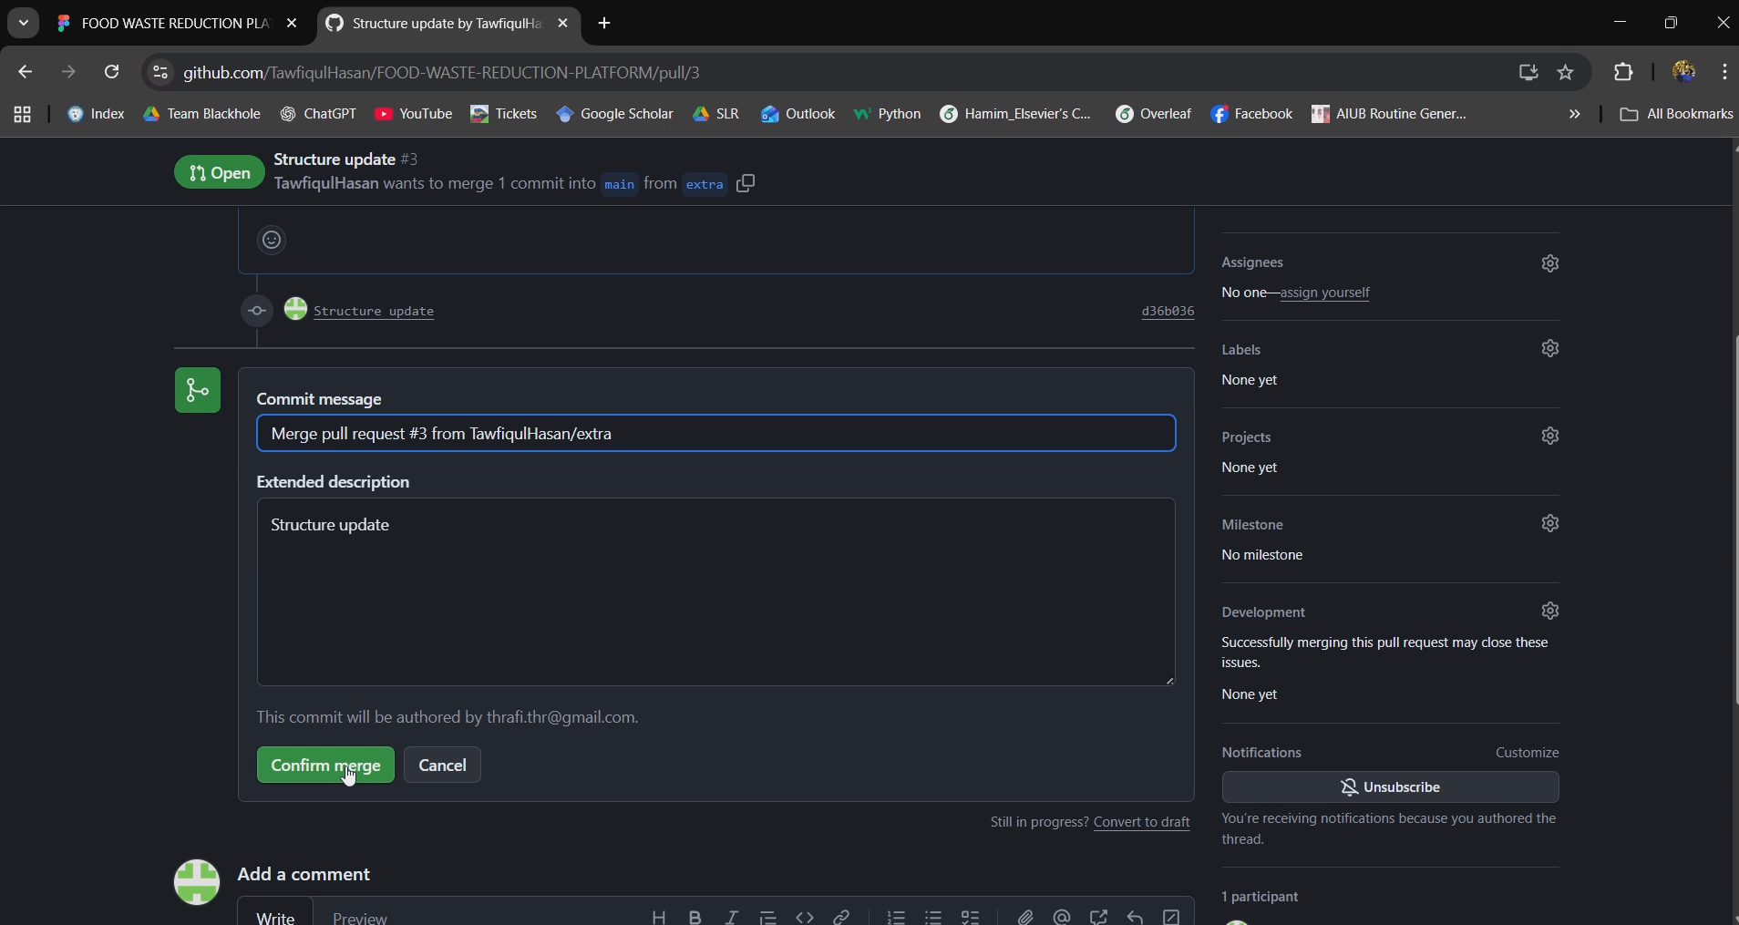

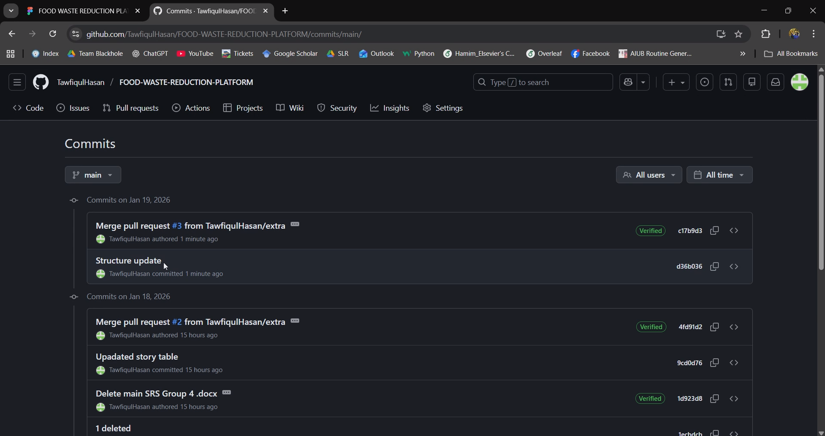

# FIGMA DESIGN

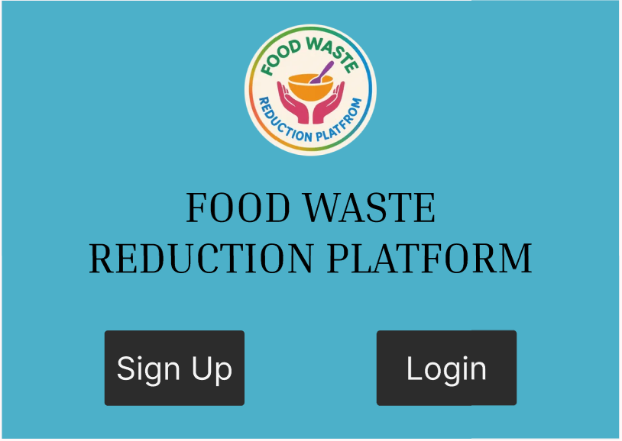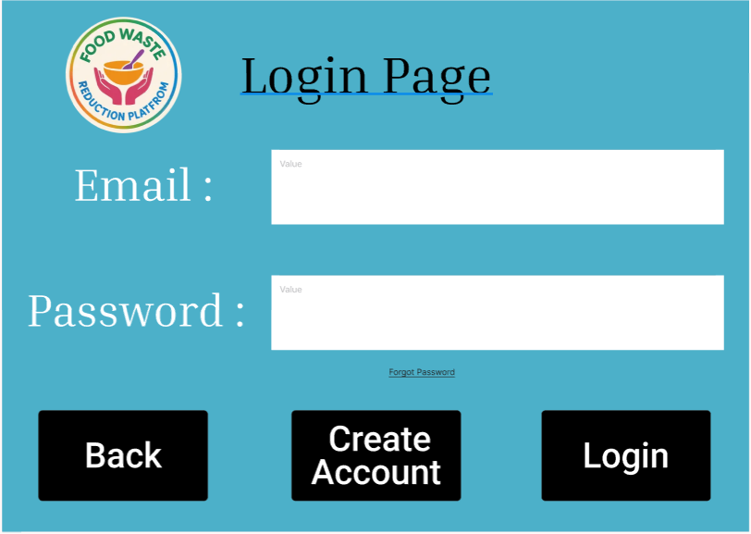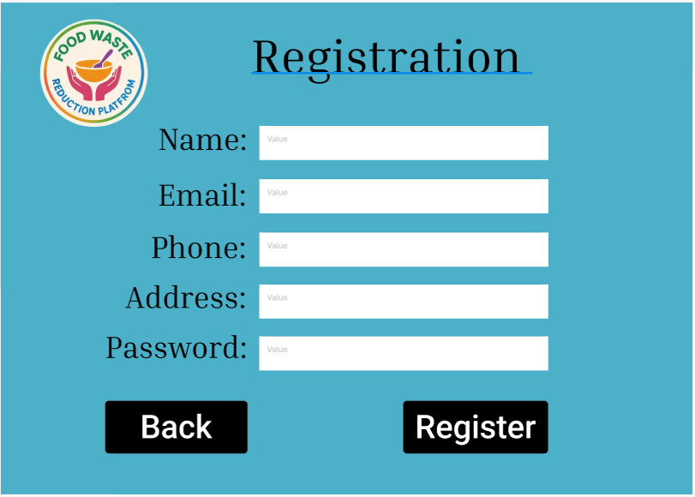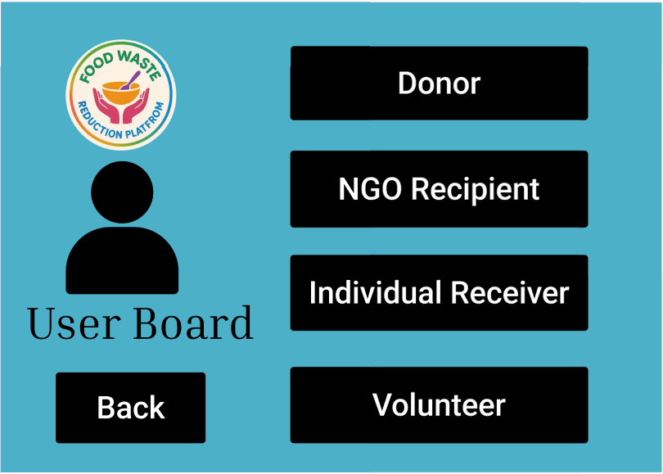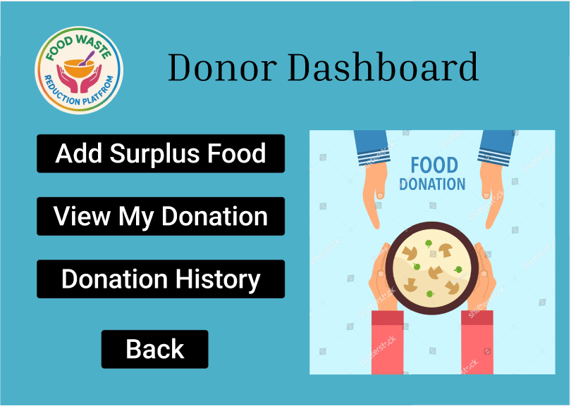

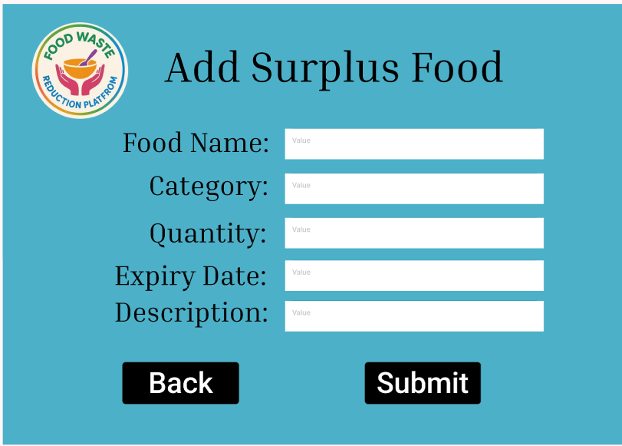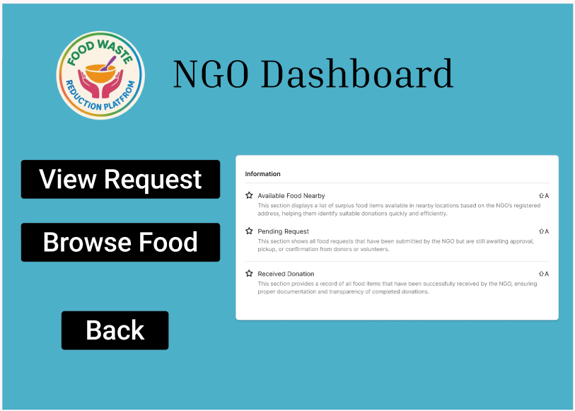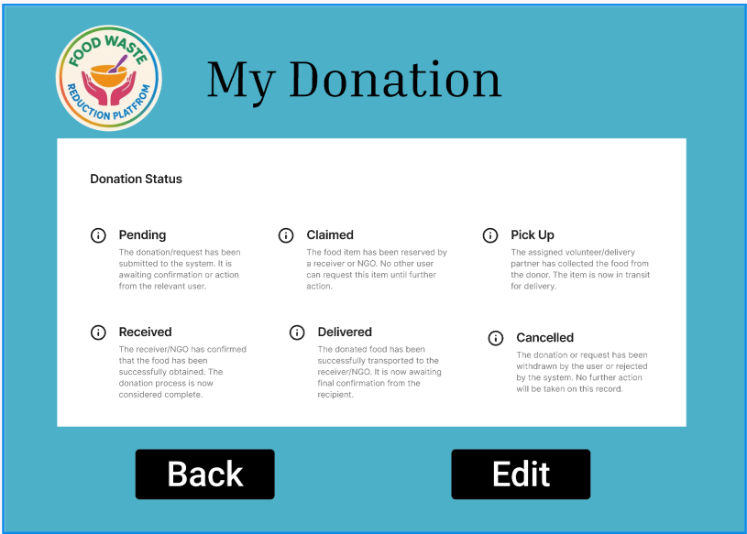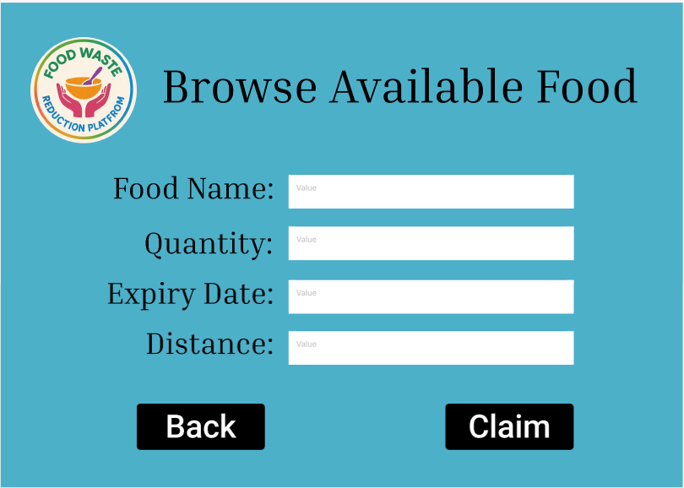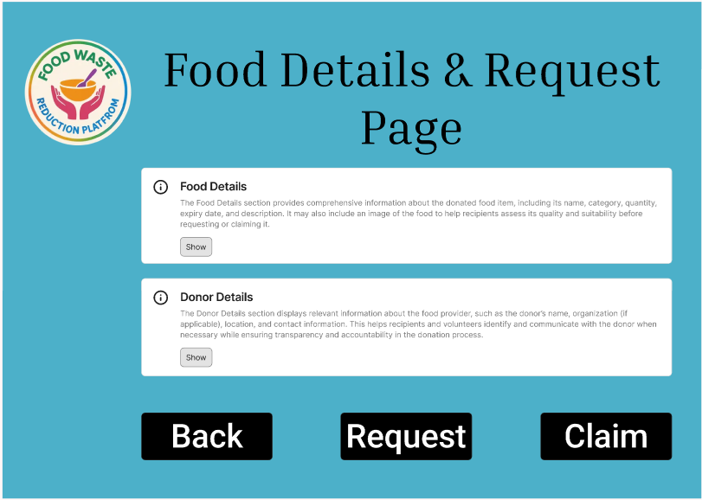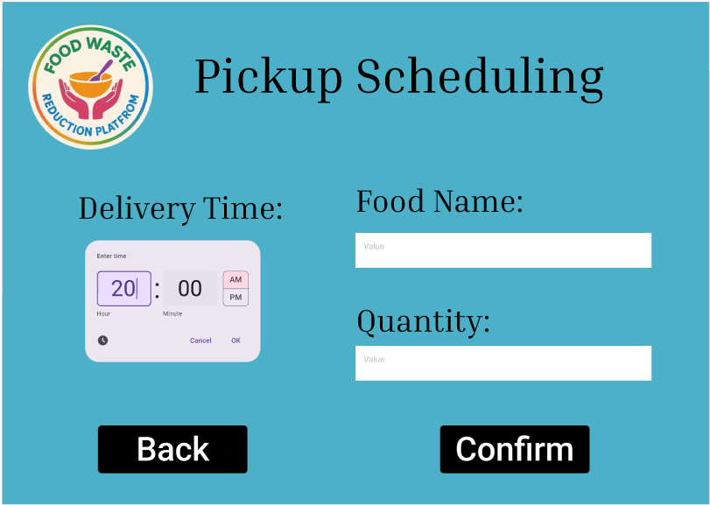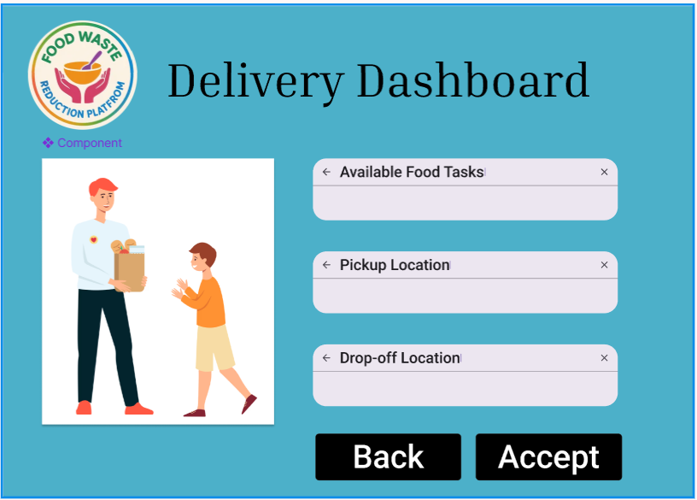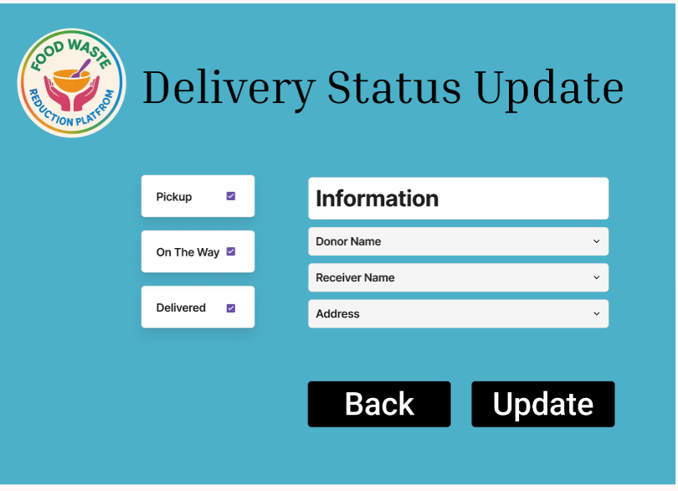

# TRELLO

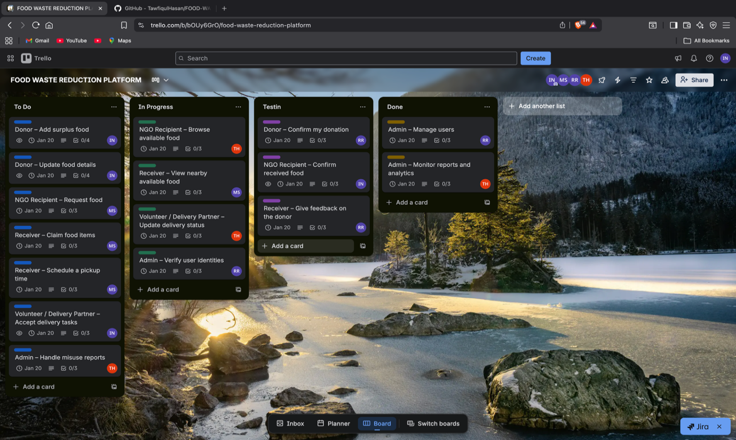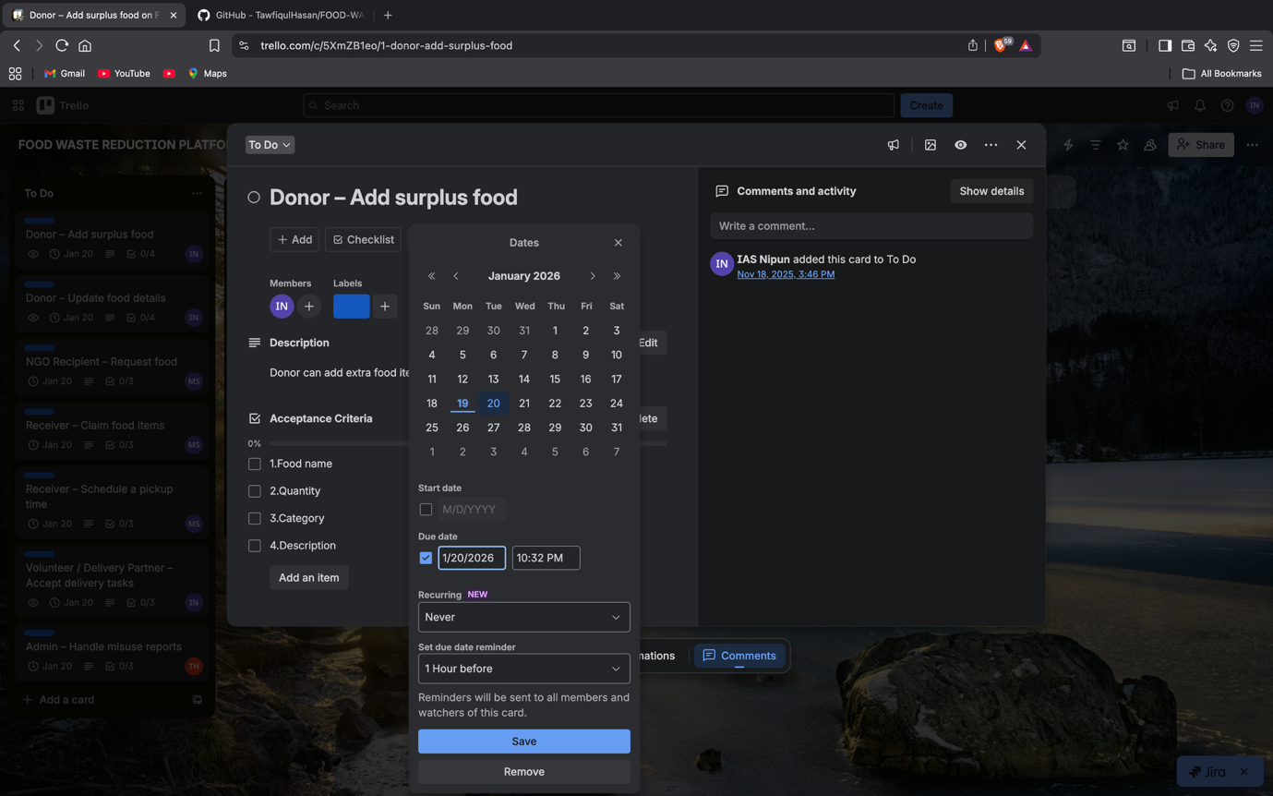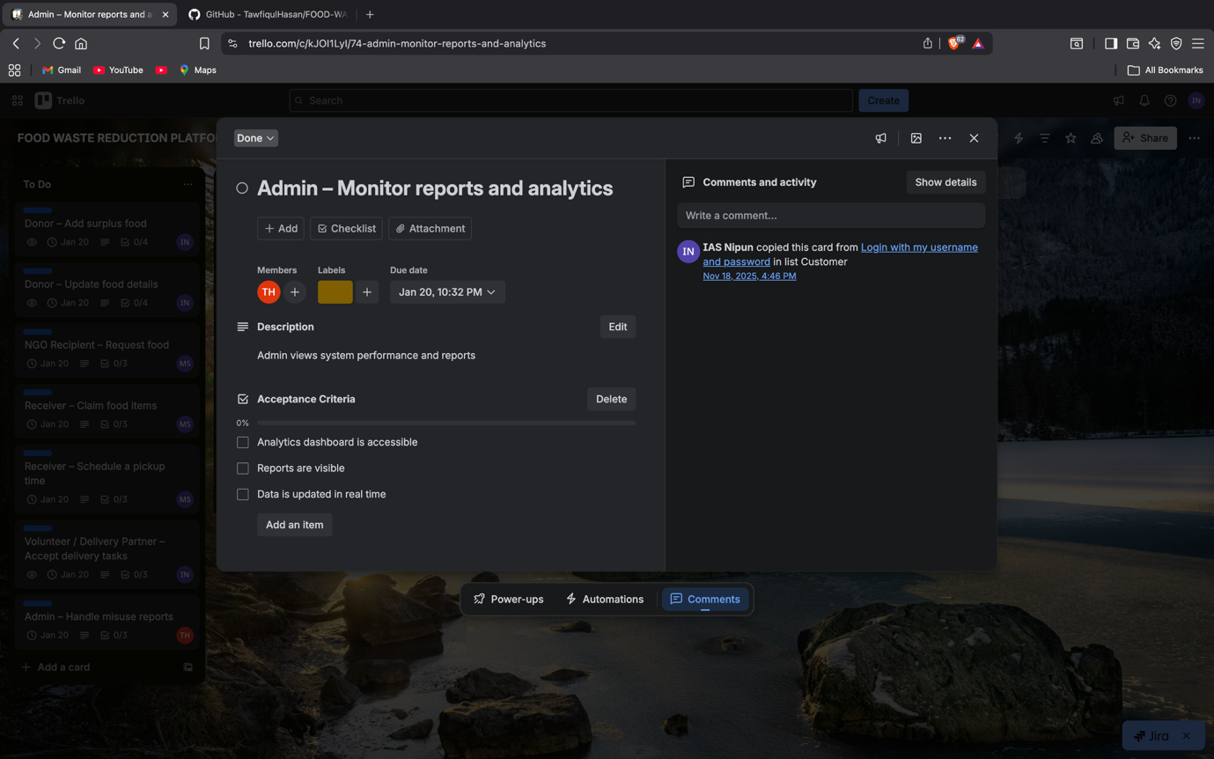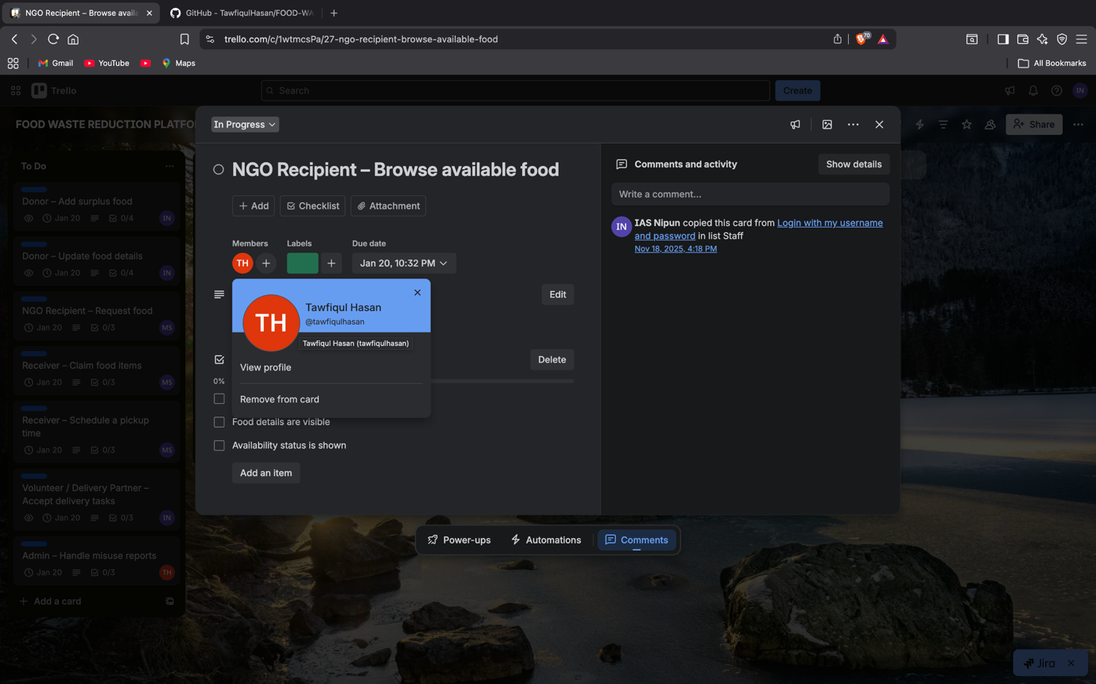

# SOFTWARE TESTING

1. Test Case:

|  |  |
| --- | --- |
| Project Name: Food Waste Reduction Platform | Test Designed by: Md. Rayatul Bari Rahin |
| Test Case ID: TC_01 | Test Designed date: 30/12/2025 |
| Test Priority: Medium | Test Executed by: Md. Rayatul Bari Rahin |
| Module Name: Login Session | Test Execution date: 30/12/2025 |
| Test Title: Verify login with valid credentials |  |
| Description: To verify that the system allows a user to log in successfully using valid username and password. |  |
| Precondition: User has valid username and password |  |
| Dependencies: |  |

|  |  |  |  |  |
| --- | --- | --- | --- | --- |
| Test Steps | Test Data | Expected Results | Actual Results | Status |
| 1. Go to login page 2. Enter valid username 3. Enter valid password 4. Click Login | 1. Username: user99  2. Password: 321 | User should successfully log in | As expected | Pass |

2. Test Case:

|  |  |
| --- | --- |
| Project Name: Food Waste Reduction Platform | Test Designed by: Md. Rayatul Bari Rahin |
| Test Case ID: TC_02 | Test Designed date: 30/12/2025 |
| Test Priority: Medium | Test Executed by: Md. Rayatul Bari Rahin |
| Module Name: Login Session | Test Execution date: 30/12/2025 |
| Test Title: Verify login with invalid password |  |
| Description: To verify that the system displays an error message when a user attempts to log in with an invalid password. |  |
| Precondition: User has valid username |  |
| Dependencies: |  |

|  |  |  |  |  |
| --- | --- | --- | --- | --- |
| Test Steps | Test Data | Expected Results | Actual Results | Status |
| 1. Go to login page 2. Enter valid username 3. Enter invalid password 4. Click Login | 1. Username: user99  2. Password: 123 | Error message should be displayed | As expected | Pass |

3. Test Case:

|  |  |
| --- | --- |
| Project Name: Food Waste Reduction Platform | Test Designed by: Md. Rayatul Bari Rahin |
| Test Case ID: TC_03 | Test Designed date: 30/12/2025 |
| Test Priority: Medium | Test Executed by: Md. Rayatul Bari Rahin |
| Module Name: Registration | Test Execution date: 30/12/2025 |
| Test Title: Verify donor registration |  |
| Description: Test whether a new donor can successfully register by providing valid details. |  |
| Precondition: The user is not registered in the system. |  |
| Dependencies: |  |

|  |  |  |  |  |
| --- | --- | --- | --- | --- |
| Test Steps | Test Data | Expected Results | Actual Results | Status |
| 1. Open the registration page 2. Select the Donor role 3. Enter all required details 4. Submit the registration form | Valid donor details | A donor account should be created successfully | As expected | Pass |

4. Test Case:

|  |  |
| --- | --- |
| Project Name: FOOD WASTE EDUCTION PLATFORM | Test Designed by: Tawfiqul Hasan |
| Test Case ID: TC_4 | Test Designed date: 12/30/2025 |
| Test Priority: Medium | Test Executed by: Tawfiqul Hasan |
| Module Name: Donor Food Listing | Test Execution date: 12/30/2025 |
| Test Title: Add surplus food |  |
| Description: Verify that donor can add surplus food with correct details |  |
| Precondition: The donor has a valid username and password and is logged into the system |  |
| Dependencies: |  |

|  |  |  |  |  |
| --- | --- | --- | --- | --- |
| Test Steps | Test Data | Expected Results | Actual Results | Status |
| 1. Go to site 2. Enter username 3. Enter password 4. Click submit 5. Click Add Food  6. Enter food details  7. Click submit | URL Username: donor01  Password: donor@123  Food: Rice, Qty: 5kg, Category: Cooked | * Website opens successfully * Username accepted * Login successful * Donor dashboard displayed * Add Food page opens * Details accepted * Food listed successfully | As expected | Pass |

5. Test Case:

|  |  |
| --- | --- |
| Project Name: FOOD WASTE REDUCTION PLATFORM | Test Designed by: Tawfiqul Hasan |
| Test Case ID: TC_5 | Test Designed date: 12/30/2025 |
| Test Priority: Medium | Test Executed by: Tawfiqul Hasan |
| Module Name: Donor Food Listing | Test Execution date: 12/30/2025 |
| Test Title: Update full detail |  |
| Description: Verify that donor can update existing food details correctly |  |
| Precondition: The donor is logged in and has already added surplus food |  |
| Dependencies: Existing food listing |  |

|  |  |  |  |  |
| --- | --- | --- | --- | --- |
| Test Steps | Test Data | Expected Results | Actual Results | Status |
| 1. Go to site 2. Enter username 3. Enter password 4. Click Submit 5. Open My Food Listings 6. Select food item 7. Update food details 8. Click Save | URL Username: donor01  Password: donor@123  Food: Rice, Qty: 7kg | * Website opens * Username accepted * Login successful * Donor dashboard displayed * Food list displayed * Food details open * Data updated * Updated food saved successfully | As expected | Pass |

6. Test Case:

|  |  |
| --- | --- |
| Project Name: FOOD WASTE REDUCTION PLATFORM | Test Designed by: Tawfiqul Hasan |
| Test Case ID: TC_6 | Test Designed date: 12/30/2025 |
| Test Priority: Medium | Test Executed by: Tawfiqul Hasan |
| Module Name: Donor Donation | Test Execution date: 12/30/2025 |
| Test Title: Confirm Donation Submission |  |
| Description: Verify that donor can confirm submitted food donation successfully |  |
| Precondition: The donor is logged in and has already added surplus food |  |
| Dependencies: Existing food listing |  |

|  |  |  |  |  |
| --- | --- | --- | --- | --- |
| Test Steps | Test Data | Expected Results | Actual Results | Status |
| 1. Go to site 2. Enter username 3. Enter password 4. Click Submit 5. Open My Donations 6. Select food item 7. Click Confirm Donation | URL Username: donor01  Password: donor@123  Food: Rice, Qty: 7kg | * Website opens successfully * Username accepted * Login successful * Donor dashboard displayed * Donation list displayed * Donation details open * Donation status changes to Confirmed | As expected | Pass |

7. Test Case:

|  |  |
| --- | --- |
| Project Name: Food Waste Reduction Platform | Test Designed by: Md. Rayatul Bari Rahin |
| Test Case ID: TC_09 | Test Designed date: 30/12/2025 |
| Test Priority: Medium | Test Executed by: Md. Rayatul Bari Rahin |
| Module Name: NGO – Receive Food | Test Execution date: 30/12/2025 |
| Test Title: Confirm received food |  |
| Description: Test whether the NGO can successfully confirm the receipt of donated food |  |
| Precondition: The food request has been approved and is ready for receipt |  |
| Dependencies: |  |

|  |  |  |  |  |
| --- | --- | --- | --- | --- |
| Test Steps | Test Data | Expected Results | Actual Results | Status |
| 1. Open the NGO dashboard 2. Navigate to the received food list 3. Select the donation 4. Click Confirm Received | Donation details | The donation status should update to Received successfully | As expected | Pass |

8. Test Case:

|  |  |
| --- | --- |
| Project Name: Food Waste Reduction System | Test Designed by: Ibna Al Shaid Nipun |
| Test Case ID: TC_10 | Test Designed date: 30/12/2025 |
| Test Priority: Medium | Test Executed by: Ibna Al Shaid Nipun |
| Module Name: Receiver – Nearby Food | Test Execution date: 30/12/2025 |
| Test Title: View nearby available food |  |
| Description: Test whether the receiver can view nearby available food items based on their current location |  |
| Precondition: The receiver is logged in with valid credentials |  |
| Dependencies: |  |

**Test Steps:**

|  |  |  |  |  |
| --- | --- | --- | --- | --- |
| Test Steps | Test Data | Expected Results | Actual Results | Status |
| 1. Open the receiver dashboard 2. Navigate to the Nearby Food section | Receiver  Location data | Food items based on the receiver’s location should be displayed | As expected | Pass |

9. Test Case:

|  |  |
| --- | --- |
| Project Name: Food Waste Reduction System | Test Designed by: Ibna Al Shaid Nipun |
| Test Case ID: TC_11 | Test Designed date: 30/12/2025 |
| Test Priority: Medium | Test Executed by: Ibna Al Shaid Nipun |
| Module Name: Receiver – Claim Food | Test Execution date: 30/12/2025 |
| Test Title: Claim food item |  |
| Description: Test whether the receiver can successfully claim an available food item |  |
| Precondition: The receiver is logged in and the food item is available for claiming |  |
| Dependences: |  |

|  |  |  |  |  |
| --- | --- | --- | --- | --- |
| Test Steps | Test Data | Expected Results | Actual Results | Status |
| 1. Open the receiver dashboard 2. Select an available food item  3. Click the Claim button | Selected food item | The food item should be reserved for the receiver successfully | As expected | Pass |

10. Test Case:

|  |  |
| --- | --- |
| Project Name: Food Waste Reduction Platform | Test Designed by: Md. Rayatul Bari Rahin |
| Test Case ID: TC_12 | Test Designed date: 30/12/2025 |
| Test Priority: Medium | Test Executed by: Md. Rayatul Bari Rahin |
| Module Name: Receiver – Pickup | Test Execution date: 30/12/2025 |
| Test Title: Schedule pickup time |  |
| Description: Test whether the receiver can successfully schedule a pickup time for a claimed food item. |  |
| Precondition: The food item has already been claimed by the receiver. |  |
| Dependencies: |  |

|  |  |  |  |  |
| --- | --- | --- | --- | --- |
| Test Steps | Test Data | Expected Results | Actual Results | Status |
| 1. Open the receiver dashboard 2. Select the claimed food item 3. Choose a pickup time 4. Click Confirm | Pickup time details | The selected pickup time should be saved successfully | As expected | Pass |

11. Test Case:

|  |  |
| --- | --- |
| Project Name: FOOD WASTE REDUCTION PLATFORM | Test Designed by: Tawfiqul Hasan |
| Test Case ID: TC_13 | Test Designed date: 12/30/2025 |
| Test Priority: Medium | Test Executed by: Tawfiqul Hasan |
| Module Name: Feedback | Test Execution date: 12/30/2025 |
| Test Title: Submit donor feedback |  |
| Description: Test whether a donor can successfully submit feedback after completing a donation. |  |
| Precondition donation completed |  |
| Dependencies: None |  |

|  |  |  |  |  |
| --- | --- | --- | --- | --- |
| Test Steps | Test Data | Expected Results | Actual Results | Status |
| 1. Open the feedback form.  2. Enter feedback details.  3. Submit the feedback. | Donor feedback  text | Feedback should be stored | As expected | Pass |

12. Test Case:

|  |  |
| --- | --- |
| Project Name: FOOD WASTE REDUCTION PLATFORM | Test Designed by: Tawfiqul Hasan |
| Test Case ID: TC_14 | Test Designed date: 12/30/2025 |
| Test Priority: Medium | Test Executed by: Tawfiqul Hasan |
| Module Name: Volunteer – Delivery | Test Execution date: 12/30/2025 |
| Test Title: Accept delivery task |  |
| Description: Test whether a volunteer can successfully accept an available delivery task. |  |
| Precondition: Delivery task available |  |
| Dependencies: None |  |

|  |  |  |  |  |
| --- | --- | --- | --- | --- |
| Test Steps | Test Data | Expected Results | Actual Results | Status |
| 1. View available delivery tasks.  2. Click on Accept for a task. | Delivery  task | Task should be assigned | As expected | Pass |

13. Test Case

|  |  |
| --- | --- |
| Project Name: Food Waste Reduction Platform | Test Designed by: Md. Tanzim Wasif Shah |
| Test Case ID: TC_15 | Test Designed date: 30/12/2025 |
| Test Priority: Medium | Test Executed by: Md. Tanzim Wasif Shah |
| Module Name: Volunteer – Delivery | Test Execution date: 05/01/2026 |
| Test Title: Update delivery status |  |
| Description: Test whether the volunteer can successfully update the delivery status during the delivery process. |  |
| Precondition: The volunteer has logged in and accepted a delivery task. |  |
| Dependencies: |  |

|  |  |  |  |  |
| --- | --- | --- | --- | --- |
| Test Steps | Test Data | Expected Results | Actual Results | Status |
| 1. Open the volunteer dashboard.  2. Select an accepted delivery task.  3. Update status to Picked Up.  4. Update status to Delivered. | Delivery Status: Picked up to Delivered. | Status should update correctly | As expected | Pass |

14. Test Case:

|  |  |
| --- | --- |
| Project Name: Food Waste Reduction Platform | Test Designed by: Md. Tanzim Wasif Shah |
| Test Case ID: TC_16 | Test Designed date: 30/12/2025 |
| Test Priority: Medium | Test Executed by: Md. Tanzim Wasif Shah |
| Module Name: Admin – User Verification | Test Execution date: 05/01/2026 |
| Test Title: Verify user identity |  |
| Description: Test whether the admin can successfully verify a user’s identity from the user management. |  |
| Precondition: The admin is logged in with valid credentials. |  |
| Dependencies: |  |

|  |  |  |  |  |
| --- | --- | --- | --- | --- |
| Test Steps | Test Data | Expected Results | Actual Results | Status |
| 1. Open the admin dashboard.  2. Navigate to the user list.  3. Select a user pending verification.  4. Verify the user | User verification action. | User should be verified | As expected | Pass |

15. Test Case:

|  |  |
| --- | --- |
| Project Name: Food Waste Reduction System | Test Designed by: Ibna Al Shaid Nipun |
| Test Case ID: TC_17 | Test Designed date: 30/12/2025 |
| Test Priority: Medium | Test Executed by: Ibna Al Shaid Nipun |
| Module Name: Admin – User Management | Test Execution date: 30/12/2025 |
| Test Title: Add new user |  |
| Description: Test whether the admin can successfully add a new user to the system |  |
| Precondition: Admin is logged in with valid credentials |  |
| Dependencies: None |  |

|  |  |  |  |  |
| --- | --- | --- | --- | --- |
| Test Steps | Test Data | Expected Results | Actual Results | Status |
| 1. Open admin dashboard 2. Navigate to User Management 3. Click on Add New User | 1. Admin credentials  2. User details 3. New user information | 1. Admin dashboard should open  2. User management page should load 3. User should be added successfully | As expected | Pass |

16. Test Case:

|  |  |
| --- | --- |
| Project Name: Food Waste Reduction System | Test Designed by: Ibna Al Shaid Nipun |
| Test Case ID: TC_18 | Test Designed date: 30/12/2025 |
| Test Priority: Medium | Test Executed by: Ibna Al Shaid Nipun |
| Module Name: Admin – User Management | Test Execution date: 30/12/2025 |
| Test Title: Update user details |  |
| Description: Test whether the admin can update existing user details successfully |  |
| Precondition: Admin is logged in and user already exists in the system |  |
| Dependencies: Existing user record |  |

|  |  |  |  |  |
| --- | --- | --- | --- | --- |
| Test Steps | Test Data | Expected Results | Actual Results | Status |
| 1. Open admin dashboard 2. Navigate to User Management 3. Edit user details and save | 1. Admin credentials  2. Existing user data 3. Updated user information | 1. Dashboard should be displayed  2. User list should be displayed 3. User details should update | As expected | Pass |

17. Test Case:

|  |  |
| --- | --- |
| Project Name: Food Waste Reduction System | Test Designed by: Ibna Al Shaid Nipun |
| Test Case ID: TC_19 | Test Designed date: 30/12/2025 |
| Test Priority: Medium | Test Executed by: Ibna Al Shaid Nipun |
| Module Name: Admin – User Management | Test Execution date: 30/12/2025 |
| Test Title: Delete user |  |
| Description: Test whether the admin can delete an existing user from the system |  |
| Precondition: Admin is logged in and user exists in the system |  |
| Dependencies: Existing user record |  |

|  |  |  |  |  |
| --- | --- | --- | --- | --- |
| Test Steps | Test Data | Expected Results | Actual Results | Status |
| 1. Open admin dashboard 2. Navigate to User Management 3. Select user and delete | 1. Admin credentials  2. User list 3. Selected user | 1. Dashboard should be displayed  2. User list should be displayed 3. User should be removed | As expected | Pass |

18. Test Case:

|  |  |
| --- | --- |
| Project Name: Food Waste Reduction Platform | Test Designed by: Md. Tanzim Wasif Shah |
| Test Case ID: TC_20 | Test Designed date: 30/12/2025 |
| Test Priority: Medium | Test Executed by: Md. Tanzim Wasif Shah |
| Module Name: Admin – Misuse Reports | Test Execution date: 05/01/2026 |
| Test Title: View misuse reports |  |
| Description: Test whether the admin can successfully view all reported misuse cases in the system. |  |
| Precondition: The admin is logged in with valid credentials. |  |
| Dependencies: |  |

|  |  |  |  |  |
| --- | --- | --- | --- | --- |
| Test Steps | Test Data | Expected Results | Actual Results | Status |
| 1. Open the admin dashboard.  2. Navigate to the Misuse Reports section. | Misuse report list | Reports should be displayed | As expected | Pass |

19. Test Case:

|  |  |
| --- | --- |
| Project Name: Food Waste Reduction Platform | Test Designed by: Md. Tanzim Wasif Shah |
| Test Case ID: TC_21 | Test Designed date: 30/12/2025 |
| Test Priority: Medium | Test Executed by: Md. Tanzim Wasif Shah |
| Module Name: Misuse Reports | Test Execution date: 05/01/2026 |
| Test Title: Resolve misuse report |  |
| Description: Test whether the admin can successfully resolve a reported misuse case. |  |
| Precondition: The admin is logged in and at least one misuse report exists. |  |
| Dependencies: TC_20 (View misuse reports) |  |

|  |  |  |  |  |
| --- | --- | --- | --- | --- |
| Test Steps | Test Data | Expected Results | Actual Results | Status |
| 1. Open the admin dashboard.  2. Navigate to the Misuse Reports section.  3. Select a reported misuse case.  4. Mark the report as resolved | Resolve action | Report should be marked resolved | As expected | Pass |

20. Test Case:

|  |  |
| --- | --- |
| Project Name: Food Waste Reduction Platform | Test Designed by: Md. Tanzim Wasif Shah |
| Test Case ID: TC_22 | Test Designed date: 30/12/2025 |
| Test Priority: Medium | Test Executed by: Md. Tanzim Wasif Shah |
| Module Name: Analytics | Test Execution date: 05/01/2026 |
| Test Title: View analytics dashboard |  |
| Description: Test whether the analytics dashboard loads correctly and displays data. |  |
| Precondition: The user (admin) is logged in with valid credentials. |  |
| Dependencies: none |  |

|  |  |  |  |  |
| --- | --- | --- | --- | --- |
| Test Steps | Test Data | Expected Results | Actual Results | Status |
| 1. Open the admin dashboard.  2. Navigate to the Analytics section. | Analytics data | Dashboard should load correctly | As expected | Pass |